5.Pips-forbs model simulation

2020112921 刘欣豪

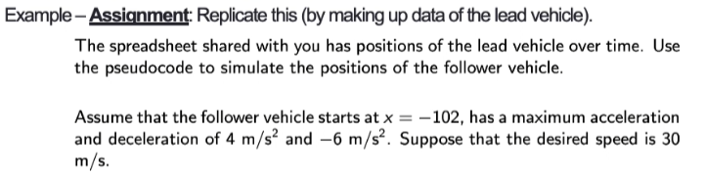

输出output表（部分）：

|  |  |  |  |  |  |
| --- | --- | --- | --- | --- | --- |
| **Time (second)** | **Position (meter) of lead car** | **speed of lead car** | **Position (meter) of follow car** | **speed of follow car** | **acceleration** |
| 0 | 2000 | 0 | -102 | 0 | 4 |
| 1 | 2000 | 0 | -98 | 4 | 4 |
| 2 | 2000 | 0 | -90 | 8 | 4 |
| 3 | 2000 | 0 | -78 | 12 | 4 |
| 4 | 2000 | 0 | -62 | 16 | 4 |
| 5 | 2000 | 0 | -42 | 20 | 4 |
| 6 | 2000 | 0 | -18 | 24 | 4 |
| 7 | 2000 | 0 | 10 | 28 | 4 |
| 8 | 2000 | 0 | 40 | 30 | 4 |
| 9 | 2000 | 0 | 70 | 30 | 4 |
| 10 | 2000 | 0 | 100 | 30 | 4 |

仿真结果：

出现撞车现象且在渐变区域不稳定。

代码：

1. **import** pandas as pd
3. datas = pd.read_excel('Lead+car+data.xlsx')
5. **for** i **in** range(0,500):
6. s = datas.iloc[i,1]-datas.iloc[i,3]
7. v = datas.iloc[i,4]
8. smin = 6 * (v/4.47 + 1)
9. #     print(smin)
10. **if** s<smin:
11. datas.iloc[i+1,4] = max(0,v-6)
12. datas.iloc[i,5] = -6
13. **else**:
14. datas.iloc[i+1,4] = min(30,v+4)
15. datas.iloc[i,5] = 4
16. datas.iloc[i+1,3] = datas.iloc[i,3]+datas.iloc[i+1,4]
18. datas.to_excel('output.xlsx',index  =False)